SQLServer Lab

Note: Use ITI DB

1. Create a view that displays student full name, course name if the student has a grade more than 50.
2. Create an Encrypted view that displays manager names and the topics they teach.
3. Create a view that will display Instructor Name, Department Name for the ‘SD’ or ‘Java’ Department
4. Create a view “V1” that displays student data for student who lives in Alex or Cairo.

Note: Prevent the users to run the following query

Update V1 set st_address=’tanta’

Where st_address=’alex’;

1. Create a view that will display the project name and the number of employees work on it. “Use Company DB”
2. Create the following schema and transfer the following tables to it
   1. Company Schema
      1. Department table (Programmatically)
      2. Project table (visually)
   2. Human Resource Schema
      1. Employee table (Programmatically)
3. Create index on column (Hiredate) that allow u to cluster the data in table Department. What will happen?
4. Create index that allow u to enter unique ages in student table. What will happen?
5. Try to generate script from DB ITI that describes all tables and views in this DB
6. Write a query that returns the Student No and Student first name without the last char
7. Wirte query to delete all grades for the students Located in SD Department
8. Using Merge statement between the following two tables [User ID, Transaction Amount]

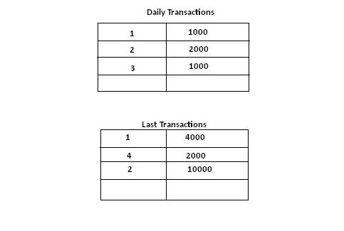

1. Try to Create Login Named(ITIStud) who can access Only student and Course tablesfrom ITI DB then allow him to select and insert data into tables and deny Delete and update